Name: ______________________ Due date: ____________

Year 8 Chemistry
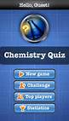
It’s Elemental

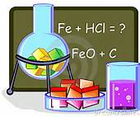

You have been hired by a media company to create a new
board game/ quiz show
which teaches people about the Periodic Table:

Work in groups of up to four students

YOUR BOARD GAME/QUIZ SHOW MUST COVER EACH OF THESE
What is the Periodic Table?
Who made this table?
How elements are named
How elements are ordered in Periodic Table
Atoms in Elements
Monatomic Elements / Molecular Elements
Differences between Metals & Non Metals / Properties
Lattice arrangements
Common Element Names & Symbols
Compounds – Molecular & Lattice
Mixtures – Gaseous, Liquid & Alloys

